|  |  |  |  |  |  |
| --- | --- | --- | --- | --- | --- |
| Date | 2-Dec-22 | | | Tester Name | Richard Belanger |
| Environment | Penfax - Test | | | Login used | TEST2 |
| Operating System | Windows | Version: | Update: | | |
| Software Used | Edge | Version: | Update: | | |
| Not Applicable | Version: | Update: | | |
| Release version | 22.4.1 | | | | |
| Title | M9.03 General Member make payment date greater than 120 days of termination | | | | |
| Test Type | Regression | | | | |
| Test Scenario | Terminate member and make payment date greater than 120 days of termination | | | | |
|  |  | | | | |
| Expected Results | The member will be terminated and paid out with correct taxes taken | | | | |
| Pass/Fail | Pass | | | JIRA# | N/A |

Describe your steps with screenshots:

Member is General and has been terminated for more than 120 days

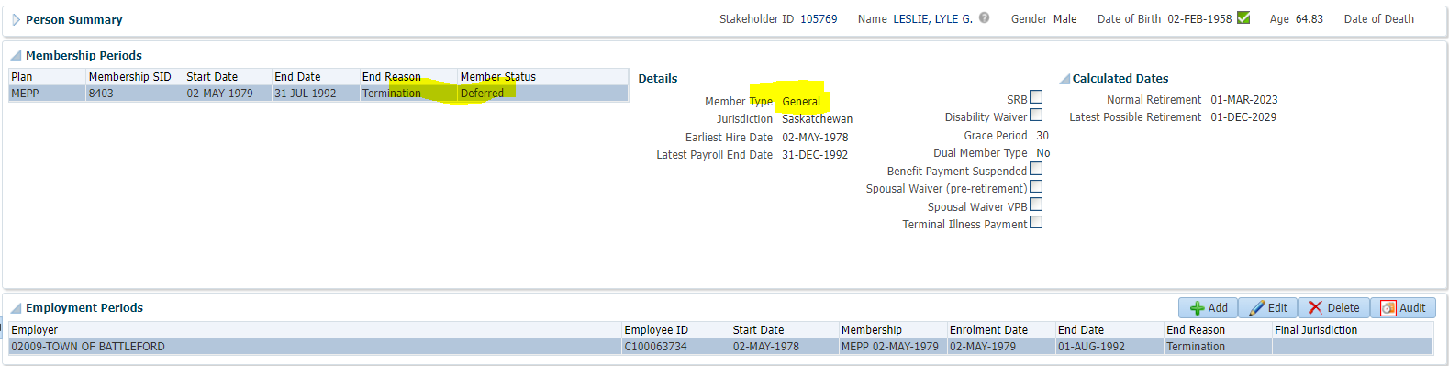

To Benefit Selection>Next

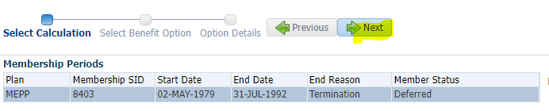

Next

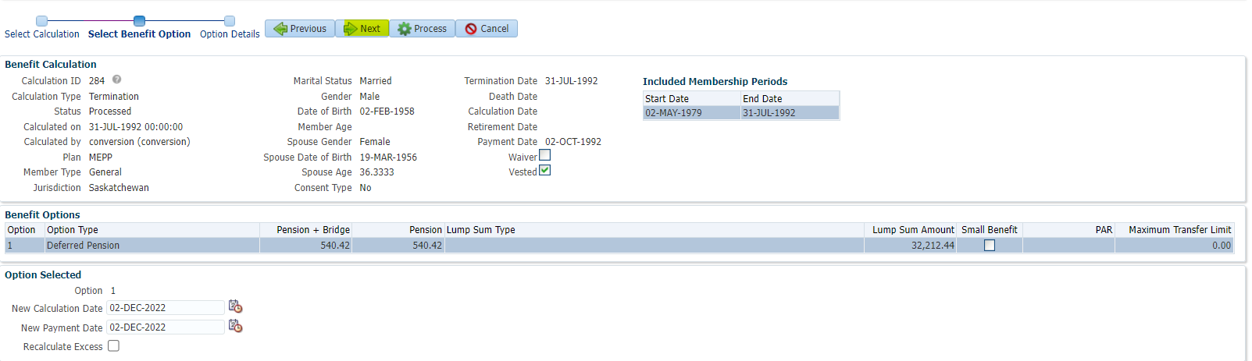

Payment Instructions added; Tax Instructions added>Process

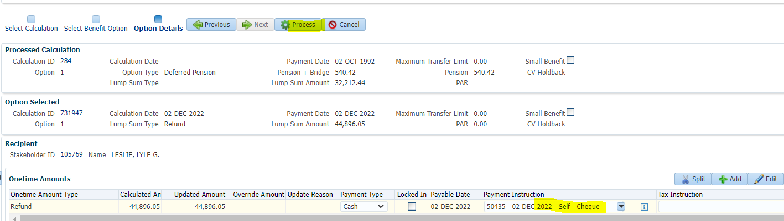

Member is Refunded

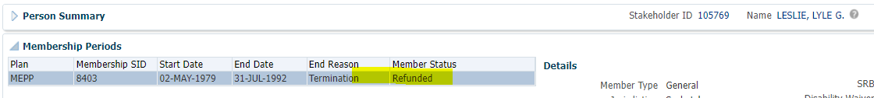

To Benefit Recipient

Onetime Amounts>Approve

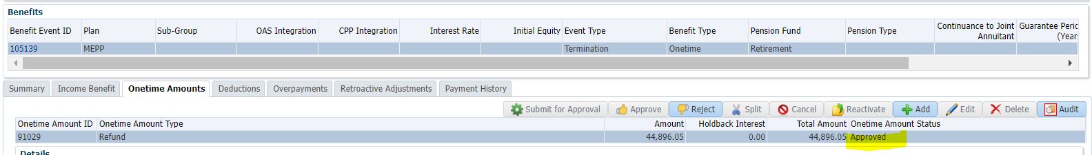

To Summary to Authorize>Authorized

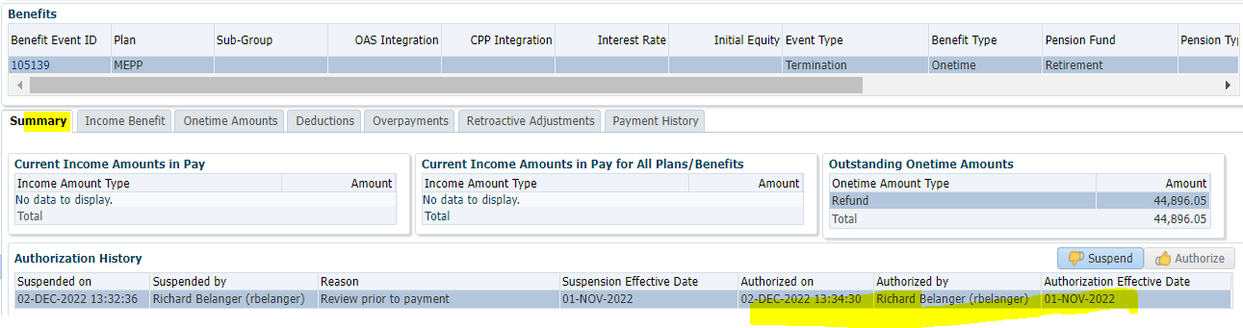

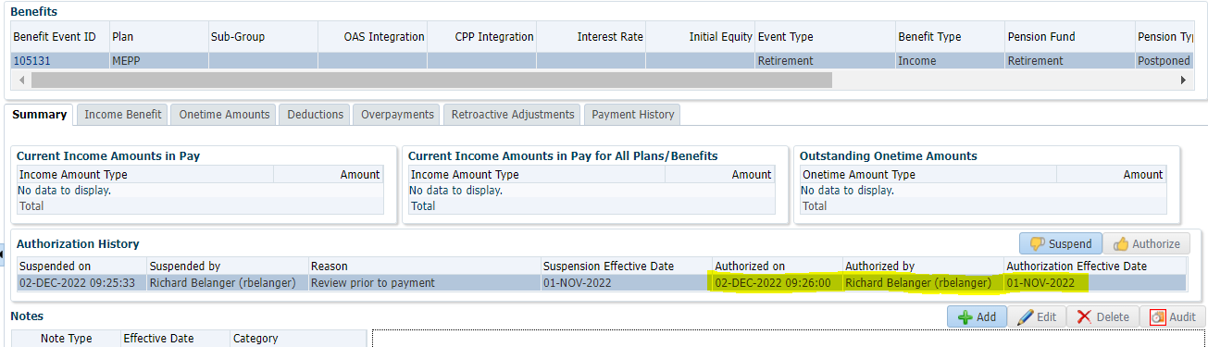

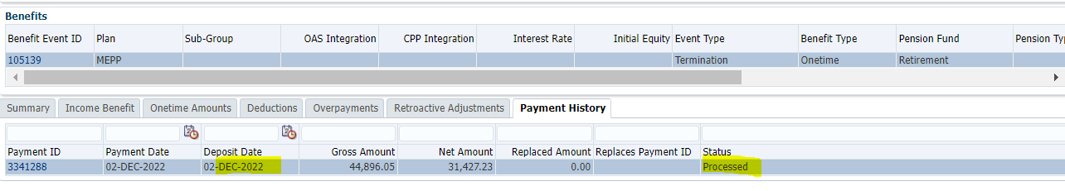

Tax Rates

0.00-4,999.99 = 10%

5,000.00- 14,999.99 = 20%

15,000.00+ = 30%

Payment is for Cash,

So…44,896.05 x 30% = 13,468.82; 44,896.05 – 13,468.82 = $31,427.23